**NAME:** SREYA G **REGISTER NO.:** 230701334

**CLASS:** CSE F **DATE:** 10/08/2024

**EX – 2:**

**FINDING TIME COMPLEXITY OF ALGORITHMS:**

PROBLEM 1:

AIM:

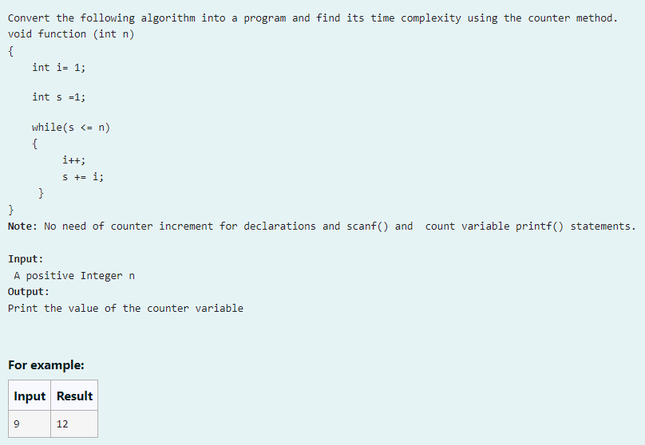

ALGORITHM:

1. Read input n.

2. Initialize counter = 0, i = 1, and s = 1.

3. Increment counter for each initialization.

4. While s <= n:

- Increment counter.

- Increment i and update s = s + i.

- Increment counter for each operation.

5. Increment counter for the final loop check.

6. Print counter.

7. End.

CODE:

#include<stdio.h>

void function(int n)

{

int counter = 0;

int i = 1;

counter++;

int s = 1;

counter++;

while(s<=n)

{

counter++;

i++;

counter++;

s = s+i;

counter++;

}

counter++;

printf("%d",counter);

}

int main()

{

int n;

scanf("%d",&n);

function(n);

return 0;

}

OUTPUT:

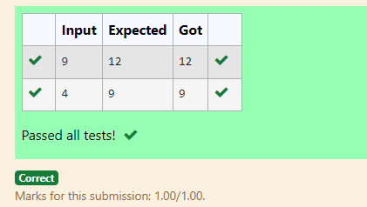

RESULT:

Thus the above code is executed successfully and gives the expected output.

PROBLEM 2:

AIM:

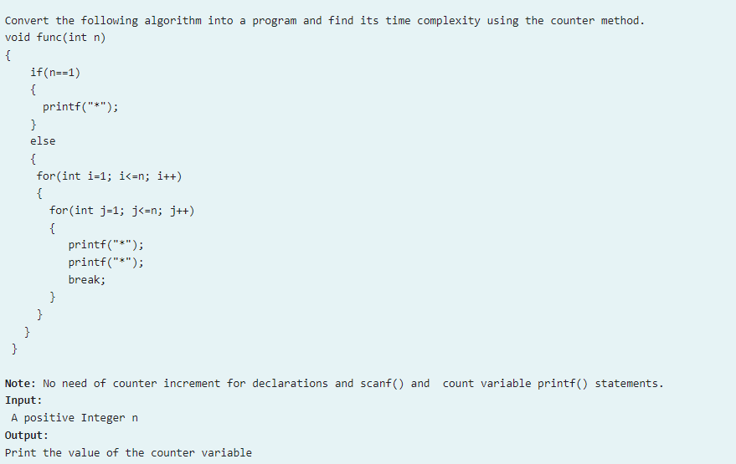

ALGORITHM:

1. Input n.

2. Initialize count = 0.

3. If n == 1:

- Increment count.

- Print "*".

4. Else:

- Increment count.

- For each i from 1 to n:

- Increment count.

- For each j from 1 to n:

- Increment count for operations and break.

- Increment count after the inner loop.

- Increment count after the outer loop.

5. Print count.

6. End.

CODE:

#include<stdio.h>

void func(int n)

{

int count = 0;

if(n==1)

{

count++;

printf("*");

}

else

{

count++;

for(int i=1;i<=n;i++)

{

count++;

for(int j=1;j<=n;j++)

{

count++;

//printf("*");

count++;

//printf("*");

count++;

break;

}

count++;

}

count++;

}

printf("%d",count);

}

int main()

{

int n;

scanf("%d",&n);

func(n);

}

OUTPUT:

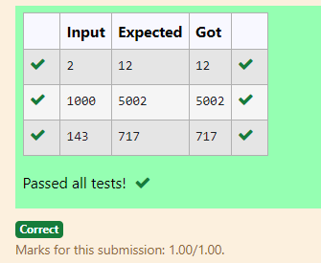

RESULT:

Thus the above code is executed successfully and gives the expected output.

PROBLEM 3:

AIM:

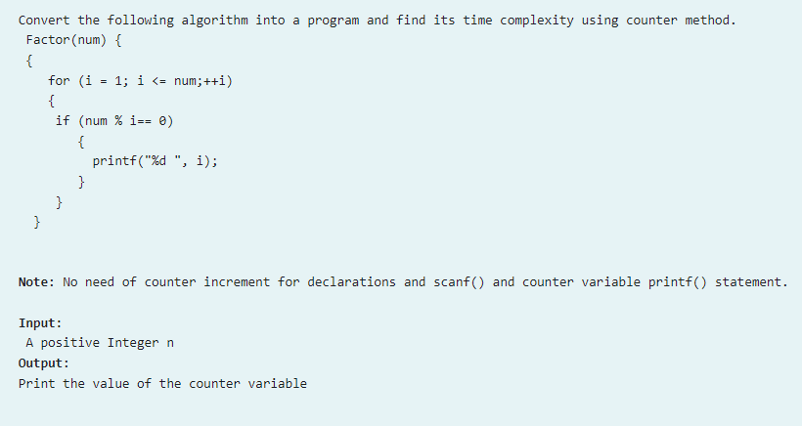

ALGORITHM:

1. Input num:

- Read an integer num from the user.

2. Initialize count = 0.

3. Iterate from i = 1 to num:

- For each iteration:

- Increment count twice (loop start and increment).

- Check if num % i == 0:

- If true, increment count.

4. After the loop, increment count once.

5. Print the value of count.

6. End.

CODE:

#include<stdio.h>

int main()

{

int num,count=0;

scanf("%d",&num);

for(int i = 1;i<=num;++i)

{

count++;

count++;

if(num%i == 0)

{

count++;

}

}

count++;

printf("%d",count);

}

OUTPUT:

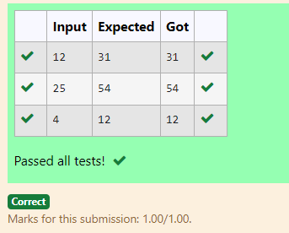

RESULT:

Thus the above code is executed successfully and gives the expected output.

PROBLEM 4:

AIM:

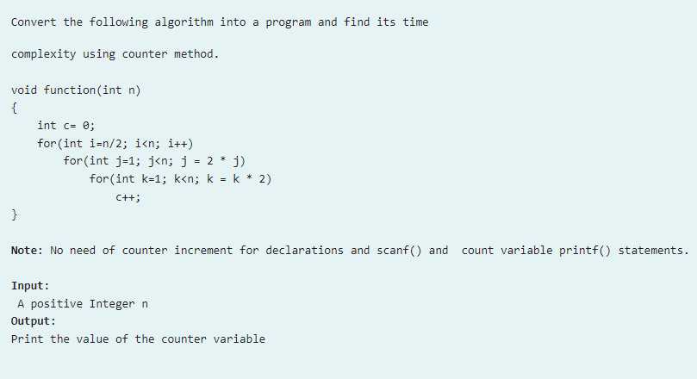

ALGORITHM:

1. Input n.

2. Initialize count = 0 and c = 0. Increment count.

3. For i from n/2 to n-1:

- Increment count.

- For j starting from 1, doubling until n-1:

- Increment count.

- For k starting from 1, doubling until n-1:

- Increment count and c.

- Increment count after the inner loop.

4. Increment count after each outer loop.

5. Increment count once after all loops.

6. Print count.

7. End.

CODE:

#include<stdio.h>

int main()

{

int n,count = 0;

scanf("%d",&n);

int c = 0;

count++;

for(int i = n/2;i < n;i++)

{

count++;

for(int j = 1;j < n;j = 2*j)

{

count++;

for(int k = 1;k < n;k = k*2)

{

count++;

c++;

count++;

}

count++;

}

count++;

}

count++;

printf("%d",count);

}

OUTPUT:

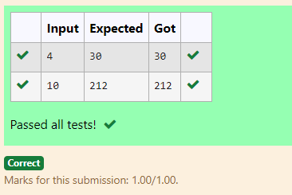

RESULT:

Thus the above code is executed successfully and gives the expected output.

PROBLEM 5:

AIM:

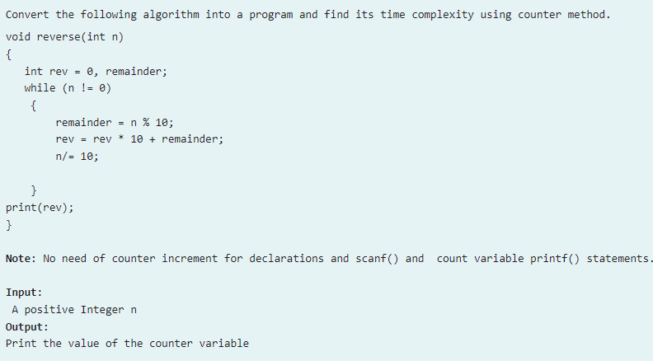

ALGORITHM:

1. Input n and initialize rev = 0, count = 0, and remainder. Increment count.

2. While n != 0:

- Increment count.

- Compute remainder = n % 10, update rev = rev * 10 + remainder, and update n = n / 10, incrementing count for each operation.

3. Increment count for the final loop condition and two additional operations.

4. Print count.

5. End.

CODE:

#include<stdio.h>

int main()

{

int n,rev = 0,count = 0,remainder;

count++;

scanf("%d",&n);

while(n!= 0)

{

count++;

remainder= n%10;

count++;

rev= rev*10+remainder;

count++;

n/=10;

count++;

}

count++;

count++;

printf("%d",count);

}

OUTPUT:

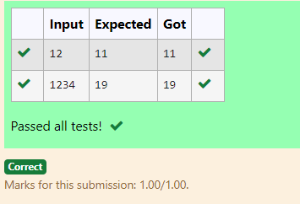

RESULT:

Thus the above code is executed successfully and gives the expected output.